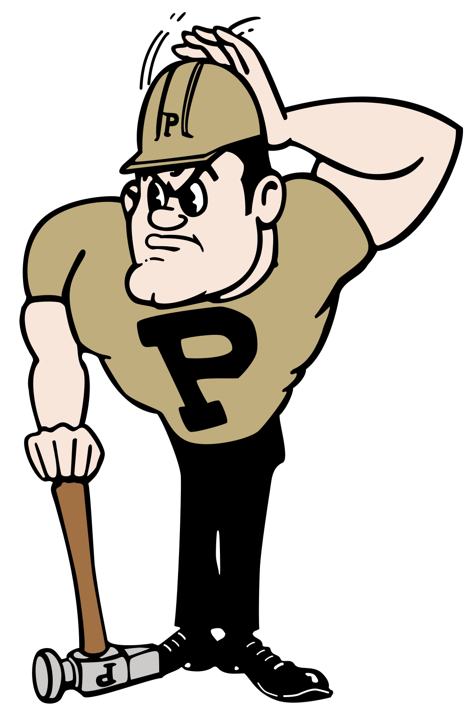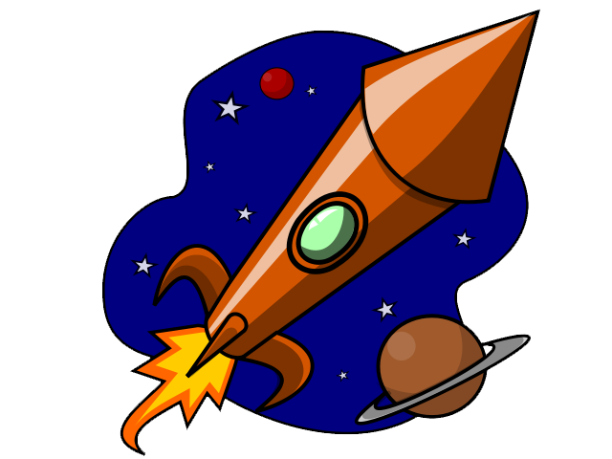

***Rockets!***

In this experiment, you will explore how your **design** and **two variables** will affect the maximum height you can reach with a water bottle rocket. The two variables you will be testing are:

* How much **pressure** to which you pump the rocket, and
* The **amount of water** that you put inside.

In order to determine how both of these variables affect the height that the rocket flies, you will keep one of them constant while we change the other. In the end you can compare the performance of your rocket with those of other teams to assess variations in design.

**Measuring Altitude**

Macintosh HD:Users:davidsederberg:Desktop:Saturday Morning Astro:Session Activities/Resources:2015-2016:Rockets:Height figure sm.pdfYou can find the altitude of your rocket, knowing the **angle** formed between lines representing the vertical height of your rocket and your line of sight, and your **distance** from the launch pad. We’ll assume you are 50 feet away.

1. Find a suitable direction moving away from the launch pad and measure a distance of 50 feet. This will define the base of the triangle and mark where the observer will stand.
2. Hold the angle finder at arms length, pointing straight to the rocket as it makes its ascent.
3. As the rocket reaches its peak, hold the string to mark the angle at maximum altitude.
4. Use the Angle-to-Altitude Table, or calculate the eye-level altitude of your rocket.
5. Add your eye-level height (to the nearest foot) to the value in the label and record that sum as the maximum altitude of your rocket.

**Safety First!**

1. You must wear safety glasses at all times while you are in the area of the launch pad.
2. **NEVER approach the launch pad of a failed launch.** If your rocket fails to disengage at launch, your supervisor will remedy the situation.
3. **Do not hold or pick up the launch cable until the rocket is pressurized and everyone has moved away from the launch pad.**

**Before you begin:** Give your rocket team a name: _________________________________

Assign jobs. Write the name of the team member who will:

1. Add water to the rocket and lock it into place on the pad _____________________
2. Pressurize to rocket with the foot pump _____________________
3. Clear the area and pull the launch cord _____________________
4. Measure the angle of the rocket at its highest point _____________________

**Materials**

* 2 liter bottle (the rocket)
* 3 sheets heavy paper
* Rocket launch pad and pump
* Clipboard
* Pencil
* Repair tape
* Hot glue guns and glue stick
* Sharpie
* Water
* Altitude finder
* Tennis ball
* Long measuring tape
* Scientific calculator

For real life engineers, limited materials is often a challenge that they have to work around. In this spirit, your team will be limited to the above items only. Plan your design with this in mind.

See how creative you can be in stretching your resources!

**Elements of Design:**

You will need to consider design features that will help you rocket achieve its maximum performance, the goal of which in this experiment will be achieving maximum altitude. Brainstorm with your group, what features you think would be most effective, and how they would help your rocket perform most efficiently and effectively. List your design goals in the table below

|  |  |  |
| --- | --- | --- |
| Design Feature | Principle Involved | Desired Effect |
|  |  |  |
|  |  |  |
|  |  |  |
|  |  |  |

**Procedure for launching the rockets:**

1. Put on your safety glasses.
2. Add the amount of water to the rocket listed in the table.
3. Quickly turn the bottle upside down and twist it onto the launch pad.
4. Lock the launch lever under the neck of the bottle.
5. Pump the bottle up to the pressure listed in the table.
6. Clear the launch area. The launcher yells **“Clear!”** before pulling the cord.
7. Pull the launch rope quickly.
8. Point the angle finder at the rocket until it reaches its maximum height and hold the string with your finger to mark the angle.
9. Determine the rocket altitude. Add your own height and record that total in the table.

**Part 1: The Effect of Pressure on Altitude**

For this part, you will use the same amount of water for each trial, but you will change how much pressure you pump into your rocket.

|  |  |  |  |
| --- | --- | --- | --- |
| **Pressure** | **How full** | **Angle at max altitude** | **Maximum altitude (incl you)** |
| **25 PSI** | $$1/3$$ |  |  |
| **40 PSI** | $$1/3$$ |  |  |
| **50 PSI** | $$1/3$$ |  |  |

State the relationship between the pressure to which the rocket is pumped and how high the rocket goes. Sketch how the would look graphically.

How high would you expect your rocket to fly if the pressure were 60 PSI? 70 PSI?

Why do you think we don’t want you testing pressures that high?

**Part 2: The Effect of Water**

In this part, you will change how much water you put in the rocket, but keep the pressure constant.

|  |  |  |  |
| --- | --- | --- | --- |
| **Pressure** | **How full** | **Angle at max altitude** | **Maximum altitude (incl you)** |
| **30 PSI** | **No water** |  |  |
| **30 PSI** | $$1/4$$ |  |  |
| **30 PSI** | $$1/2$$ |  |  |

How did changing the amount of water affect how high the rocket flew? Can you sketch this relationship as a graph?

**Wrap-up**

What do you think has a greater effect on how high the rocket goes, water or pressure?

If you think about your rocket as a model of a real rocket, what part of your rocket corresponds to the fuel in a real rocket?

What sources of error do you think may contribute to your experiment?

**Finding Altitude Option 1 – Angle to Altitude Table**

For someone standing 50 feet away from the launch pad

(This is the height above your head. Before you record in the data tables above, remember to add your own height to what is listed below)

What is your height at eye level?: ___________________

|  |  |
| --- | --- |
| **Angle (degrees)** | **Altitude (feet)** |
| 85 | 4.4 |
| 80 | 8.8 |
| 75 | 13.4 |
| 70 | 18.2 |
| 67 | 21.2 |
| 64 | 24.4 |
| 61 | 27.7 |
| 58 | 31.2 |
| 55 | 35.0 |
| 52 | 39.1 |
| 49 | 43.4 |
| 46 | 48.3 |
| 43 | 53.6 |
| 40 | 59.6 |
| 37 | 66.4 |
| 34 | 74.1 |
| 31 | 83.2 |
| 28 | 94.0 |
| 25 | 107.2 |

**Finding Altitude Option 2 – Calculation Altitude from Angle of View**

For an accurate measurement of the altitude, based on the angle of view, follow these steps:

1. Measure and record the distance from the observer to the point of the rocket’s maximum altitude (this may differ from trial to trial). ____________
2. Measure and record the height of your eye level. ____________
3. Record the angle of view you measured with the protractor and string. Here is an example:

|  |  |
| --- | --- |
| This picture shows an angle of about 55 degrees. So 55 degrees is the angle that corresponds to one of vertices of a triangle. It is the same angle as in the picture on the previous page. (Why? Try to imagine the string being the hypotenuse of the triangle) | C:\Users\Andrey\AppData\Local\Microsoft\Windows\INetCache\Content.Word\clinometer.jpg |

1. Now use one of the trigonometric functions to find the altitude. Here is a picture to help you figure out which function to use.

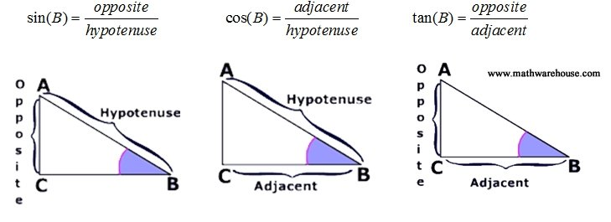

Example: If B = your angle and you want to find the adjacent side of the triangle, you can use $adjacent=hypotenuse*\cos{(B)}$

1. Once you have the altitude of the rocket calculated, don’t forget to add the height of your eye level to measure how high the rocket went from the ground.



*http://www.physics.purdue.edu/outreach/index.html*